Field Report: Northern Estuary
This report covers the spring survey of the northern estuary, with provisional figures. Highlighted text marks open questions.

1 Methods
Gauges were read at high and low water, in three steps:
- Calibrate each gauge against the datum.
- Read it every fifteen minutes.
- Reject gaps longer than a month.
Equipment used:
- Pressure gauges
- Radar level sensors
- A survey boat

1.1 Sites
Site | Gauges | Median rise (mm/yr)
Harbour mouth | 5 | 4.1
Mid estuary | 4 | 3.2
Upper reach | 3 | 2.7

2 Results
Raising the barrier crest by 40 centimetres halves the expected annual damage in the northern estuary.
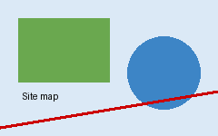
Figure 1: the surveyed sites.

3 Discussion
The central and southern estuaries gain less, because their defences are already above the 2050 line.

